Key News
- Dhaka stocks continue to fall
- Higher non-operating income: State-run energy companies deviating from business norm
- City Bank, BAU in agri research deal
- Islami Bank in DSE's weekly gainers' list
- Aramit's profit halves in Oct-Dec
- Depositors withdraw Tk 11,426cr from Islamic banks in 3 months
- Microcredit booms as rural people opt for hassle-free loans
- US dollar holds seven-week high

Stock Market & Company
Dhaka stocks continue to fall
The New Age, February 25, 2023
- Dhaka stocks declined for the fourth week in the past week as investors continued selling shares as they could not see any sign of recovery from prolonged bearishness. DSEX, the main index of the Dhaka Stock Exchange, dropped by 0.66 per cent, or 41.09 points, to close at 6,205.12 points on February 23.
- The DSEX lost 92 points in the last four weeks. The weekly average turnover plunged to Tk 273.12 crore in the past week from that of Tk 422.23 crore in the previous week.
- The DS30, comprised of 30 large capitalised companies, shed 2.86 points to finish at 2,221.34 points, and the DSE Shariah index, DSES, lost 10.76 points to close at 1,355.86 points.
- Bangladesh Shipping Corporation topped the weekly turnover chart with a value of Tk 75.99 crore. Genex Infosys, Shinepukur Ceramics, Sea Pearl Beach & Spa Limited, Olympic Industries, Gemini Sea Food, Aamra Networks, Orion Pharma, Apex Footwear and Monno Agro were the other turnover leaders.
https://www.newagebd.net/article/195344/dhaka-stocks-continue-to-fall
Higher non-operating income: State-run energy companies deviating from business norm
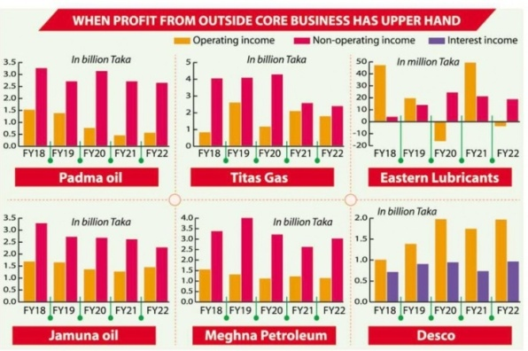
The Financial Express, February 26, 2023
- TITAS Gas Transmission & Distribution Company's profit grew at 27 per cent year-on-year for the October-December quarter of the FY23, mainly riding on non-operating income.
- Its non-operating income was Tk 674.89 million in the quarter while operating income was Tk 543.66 million.
- Dhaka Electric Supply Company Limited (Desco) is, however, an exception with operating income higher than interest income.

- TITAS Gas distributed 10-26 per cent cash dividends over the last 25 years, and its dividend yields, according to the Dhaka Stock Exchange (DSE), stood between 2.34 per cent and 8.75 per cent, annualised.
- The company issued 5 per cent stock dividend in 2012 for the last time, meaning that it has not gone for any expansion for more than a decade. Padma Oil, which yielded between 5.64 and 7.52 per cent annually over the last five years, also has not executed any expansion plan after 2013. Both Jamuna Oil Company and Meghna Petroleum issued 10 per cent stock dividend in 2014.
https://thefinancialexpress.com.bd/stock/higher-non-operating-income-state-energy-companies-deviating-from-business-norm
City Bank, BAU in agri research deal
The Daily Star, February 26, 2023

- City Bank and Bangladesh Agricultural University (BAU) recently signed a memorandum of understanding (MoU) on financial assistance for agricultural research and development to ensure sustainable food security in Bangladesh.
- Mashrur Arefin, managing director and CEO of the bank, and Prof Lutful Hassan, vice-chancellor of the university, signed the deal at City Bank Centre in Dhaka, said a press release.
- Under the deal, both organisations will work together to establish a knowledge partnership which will assist education and human resources development in the field of agriculture with the objective to increase agricultural production and its quality, capacity building and innovation.
https://www.thedailystar.net/business/economy/news/city-bank-bau-agri-research-deal-3257291
Islami Bank in DSE's weekly gainers' list
The Business Standard, February 25, 2023
- Islami Bank Bangladesh Ltd (IBBL) – one of the leading banks in the country that recently came under fire due to lending irregularities and liquidity crisis – have been included in the weekly gainers' list of the Dhaka Stock Exchange (DSE).
- According to DSE, the shariah based bank secured the ninth spot in the top ten gainers list for the last week with a 0.61% share price hike. At the end of the last week, its share price closed at Tk33.40. Throughout the week, its shares turnover value was Tk1.64 crore.
- Besides, ICB AMCL CMSF Golden Jubilee Mutual Fund was the top gainer in the list as its unit price jumped by 20% throughout the last week. Rupali Life Insurance and Monno Agro secured second and third places respectively in the list.
https://www.tbsnews.net/economy/stocks/islami-bank-dses-weekly-gainers-list-590514
Aramit's profit halves in Oct-Dec
The Financial Express, February 24, 2023
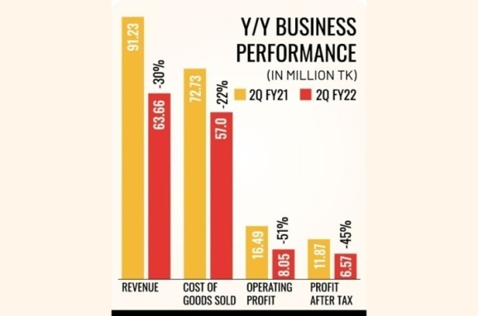
- Aramit Ltd saw a whopping 45 per cent year-on-year fall in profit in October-December (Q2) of the FY22. Though the company's expenses declined, including the cost of goods sold, it failed to secure a positive profit growth as the revenue dropped significantly.
- The revenue slumped 30 per cent to Tk 63.66 million for the second quarter of FY22, compared to the same period of the previous fiscal year.
- Operating profit dipped 51 per cent year-on-year to Tk 8.05 million for the quarter. Aramit Ltd., however, was able to reduce its negative operating cash flow in Q2, FY22, compared to the same quarter of the previous fiscal year.
- It reported a net operating cash flow per share (NOCFPS) of Tk (0.22) for Q2, FY22, down from Tk (8.92) for Q2, FY21.
https://thefinancialexpress.com.bd/stock/aramits-profit-halves-in-oct-dec-1677206679
Economy & Industry
Depositors withdraw Tk 11,426cr from Islamic banks in 3 months
The Daily Star, February 23, 2023
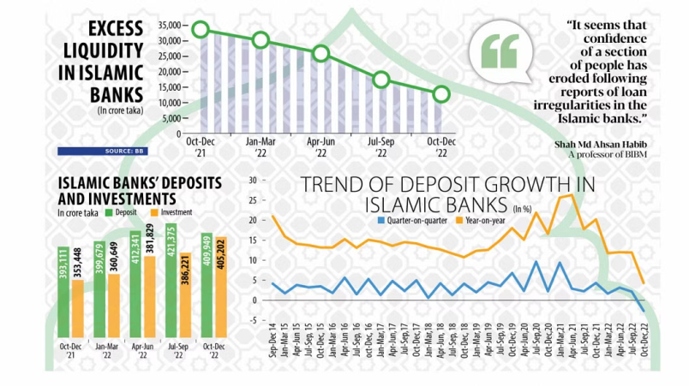
- Deposit flow to Islamic banks in Bangladesh registered a fall in the fourth quarter of 2022, the first such decline in eight years, in a sign of erosion of confidence among savers owing to loan irregularities. Data released yesterday by the Bangladesh Bank showed that total deposits in Islamic banks declined to Tk 409,949 crore at the end of December 2022, down 2.71 per cent from Tk 421,375 crore in September.
- This means Islamic banks lost Tk 11,426 crore in deposits in the three months, according to the October-December quarterly report on Islamic banking of the central bank.
- Full-fledged Islamic banks, now numbered 10, were the biggest sufferers as they lost Tk 11,842 crore in the fourth quarter from the third quarter. They collectively held deposits of Tk 379,951 crore in December, down 3 per cent from Tk 391,792 crore in September.
- Islamic banks, however, recorded a 4.28 per cent year-on-year deposit growth in the fourth quarter. Yet, the growth was the lowest since 2014, the year when the central bank started to release the quarterly report on Islamic banking.
https://www.thedailystar.net/business/economy/news/depositors-withdraw-tk-11426cr-islamic-banks-3-months-3255956
Microcredit booms as rural people opt for hassle-free loans

The Business Standard, February 25, 2023
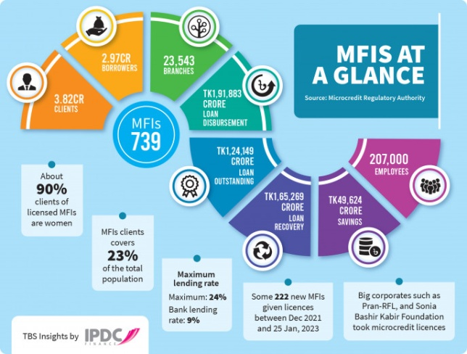
- After two years of pandemic struggles, small businesses and entrepreneurs in rural Bangladesh started to turn around last year driving up the credit appetite for household-owned workshops, agriculture, cattle farming, fisheries and three-wheelers. In addition, the war-fuelled inflation has also forced many to turn to micro-loans to meet needs.
- Data shows that the disbursement in the first six months of FY23 is on an uptrend to Tk1.10 lakh crore.
- In FY22, the microfinance institutions disbursed loans of around Tk1.92 lakh crore, which marks an impressive 27% year-on-year growth.
- Besides, some 222 new micro-lenders were approved in the last 14 months to meet the burgeoning loan demand, according to the Microcredit Regulatory Authority (MRA).
- According to the Microcredit Regulatory Authority, MRA-licenced microfinance institutions disbursed more than Tk1.91 lakh crore in FY22 – up from Tk1.51 lakh crore in FY21 and Tk1.36 lakh crore in FY20. According to the regulator, most of the newly approved micro-lenders have already started operations, while, sources said, local consumer goods giant Pran-RFL has recently taken a microcredit licence as the rural micro-lending looks promising.
https://www.tbsnews.net/economy/banking/microcredit-booms-rural-people-opt-hassle-free-loans-590746

International
US dollar holds seven-week high
The Daily Star, February 26, 2023
- The dollar held a seven-week peak on Friday, as another round of data showing still-high inflation reinforced expectations that interest rates could stay higher for longer.
- Hotter-than-expected data has helped the greenback to strengthen against many of its major peers this week, sending the dollar index up 0.6 per cent at 105.20 to a seven-week high and putting it on track to post its largest weekly gain since late September.
- The euro was also on pace to post its biggest weekly loss against the dollar since late September. Stoking the dollar's recent surge is the personal consumption expenditures (PCE) price index, tracked by the Federal Reserve for monetary policy, which rose 0.6 per cent last month after gaining 0.2 per cent in December. The PCE price index accelerated 5.4 per cent in the 12 months through January, after rising 5.3 per cent in December.
- Consumer spending, which accounts for more than two-thirds of US economic activity, jumped 1.8 per cent last month, according to the Commerce Department. December's data was revised higher to show spending dipping 0.1 per cent instead of falling 0.2 per cent as previously reported. Moreover, sales of new US single-family homes increased 7.2 per cent in January, the highest level since March 2022. December's sales pace was revised higher to 625,000 units from the previously reported 616,000.
https://www.thedailystar.net/business/global-economy/news/us-dollar-holds-seven-week-high-3257246

Disclaimer
This document has been prepared by Bank Asia Securities ltd (BASL) based on publicly available data for information purpose only and does not solicit any action based on the material contained herein and should not be construed as an offer or solicitation to buy or sell or subscribe to any security. Neither BASL nor any of its directors, shareholders, member of the management or employee represents or warrants expressly or impliedly that the information or data of the sources used in the documents are genuine, accurate, complete, authentic and correct. However, all reasonable care has been taken to ensure the accuracy of the contents of this document. BASL or Research & Development Department will not take any responsibility for any decisions made based on the information herein. As this document has been made for the Traders of BASL and strongly prohibited for circulation to any clients, investors or any other persons from outside of BASL.

About Bank Asia Securities Ltd
Bank Asia Securities Limited (BASL) is one of the leading full-service brokerage companies in Bangladesh. The company was formed in 2009 and running its operation as a majority owned subsidiary of Bank Asia Limited. BASL offers full-fledged standard brokerage services for retail, institutional and foreign clients with a dedicated team of skilled professionals. The company is currently providing the brokerage services under the membership of Dhaka Stock Exchange Limited (DSE).

BASL Research Team
Mr. Shariful Alam Chowdhury  Head of Research & Investments | tushar@basl-bd.com
Mr. Shohidul Islam  Research Analyst | shohidul@basl-bd.com

BASL Networks

For International Trade & Sales, please call at +8801993111666, +880 02 9515826, Ext: 101 at Business hour.For further query, write to us at research@basl-bd.com.

